**Independent Practice**

1 Arrange the following structures from smallest to largest;

Gene Chromosome Nucleotide Phosphate

|  |
| --- |
|  |

2 Circle the sex chromosomes shown in in the human karyotype below.

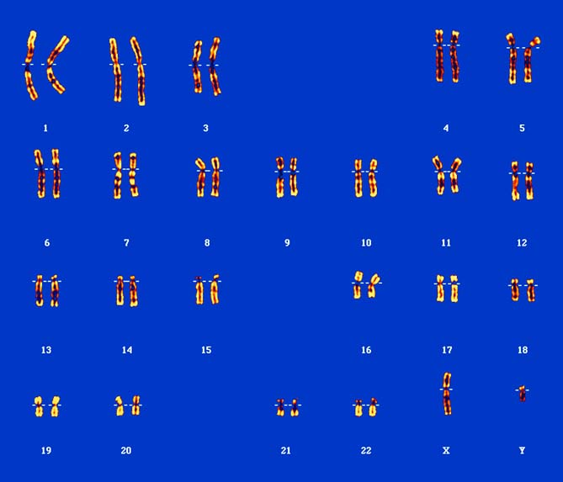

3 Is the karyotype above for a male or a female? How can you tell?

|  |
| --- |
|  |
|  |

4 If unravelled, the DNA of a single cell would be approximately 2 metres long. Explain how it fits inside a cell.

|  |
| --- |
|  |
|  |
|  |

5 A gene is a section of DNA. Explain what makes one gene different from any other gene within a DNA strand.

|  |
| --- |
|  |
|  |
|  |